The AGORA Approach

TC3 has played a major role in proposing and creating the AGORA Approach. It is now an IFIP project as part of the new IFIP Strategy.
The AGORA Initiative, an element of the process of revitalisation of the IFIP strategy, aims at implementing a dynamic methodology for initiating cooperation projects on Lifelong Learning with many different stakeholders.
It is providing a methodical concept of action where contextual local efforts are connected to each other and contribute to generic common knowledge about Lifelong Learning in a synergetic manner.

TC 3 planning group:
Jan Wibe, TC 3 chair
Bernard Cornu, TC 3 secretary
Raymond Morel, IFIP Councillor and member of IFIP Board.
Involved in the panning and implementation of AGORA is also Tom van Weert, Mike Kendall, Johannes Magenheim and Barbara Kedzierska.

Agora events:
So far we have arranged the following events:
- Conference: Poitiers, France. October, 2006
- Conference: Seoul, Korea. June, 2007
- Seminar: Addis Abeba, Ethiopia. August, 2007
- Conference: Krakow, Poland. May 2008
- Conference: LYICT 2008, Kuala Lumpur, July 2008
Future events:
- Conference: WCC 2008. Milan, Italy. September 2008
- Conference: WCCE 2009. Bento Gonsalves. Brasil. July 2009
- Conference: London, UK. 2010. IFIP 50th anniversary event.

Ateliers and Studios:
The core of the AGORA Approach is the concepts of Ateliers and Studios:
The Ateliers function is to generate generic knowledge based on the implementation experience in different local contexts, called Studios.
In the Atelier the local experiences are brought together to learn from. Generic knowledge developed from these experiences in the Atelier will help the local studio implementation. In this case studio’s would be implementations that national computer societies realise in their national environment.
The Atelier can be realised as part of normal IFIP TC activities, bringing together TC-members and national computer society professionals. Basically an Atelier is a community of interest.

Generic Structure AGORA - Project
The following figure may illustrate the fundamental concepts of AGORA:

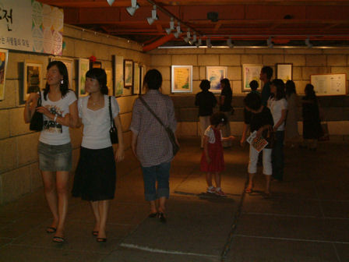
Local Project 1
contextualized
Local Project 2
contextualized
Local Project 3
contextualized
Local Project 1
contextualized
Local Project 1
contextualized
Local Project 1
contextualized
Local Project n
contextualized
- Need of sharing Experience, Knowledge
- how does LLL work in different ultures….?
- Co-ordinating Activities, Coaching
Studio
Atelier
Objectives I Methods I Studio I I Studio II I Further Action

Short about the products from AGORA so far:
The first AGORA conference:
Poitiers, France, October 26 – 27, 2006.
After many presentations and discussions, we ended up with three projects (studios):
- A: digital solidarity (crossing the digital divide)
- B: an IFIPWIKI as demonstration within IFIP
- C: IFIP Seminar on Lifelong Learning (in connection with WITFOR 2007
These projects were later changed during the Seoul conference.

The second AGORA conference:
Seoul, South Korea, June 4 – 5, 2007.
The methodical concept of “Atelier” was developed. The function of an “Atelier” is to generate generic knowledge based on the experience in different “studios”.
The four first AGORA studios were created during the Seoul seminar. These are:
1: The “Cyber-Teacher”.
2: The “Digital Divide”.
3: “How to manage and administrate Lifelong Learning”.
4: The “Croatian Studio”.

Agora Seminar:
The seminar was arranged in Addis Ababa, Ethiopia, August 19 – 21, 2007. The seminar was immediately before WITFOR 2007.
Two case studies were produced:
1: National computer societies – the role of TC’s.
By Jan Wibe and Tom van Weert.
2: School and Community Transformation Project using ICT.
By Paul Nleya, Botswana.

Conference: LYICT 2008, Kuala Lumpur, July 2008.
URL: http://cidt.oum.edu.my/lyict/
AGORA workshops were arranged for two full days, July 7 and 8 with the following workshops:
July 7:
Bridging Digitial Divide By Means Of ICT In Secondary Education
Chair: J. Magenheim
Collaborative Learning Strategies Against Digital Divide
Chair: B. Kedzierska
July 8:
Methodology of Teaching and Learning Against Digital Divide
Chair: J. Wibe
Lifelong Learning in Higher And Further Education
Chair: R. Morel.
Reports from the workshops will be submitted later in the fall of 2008.

